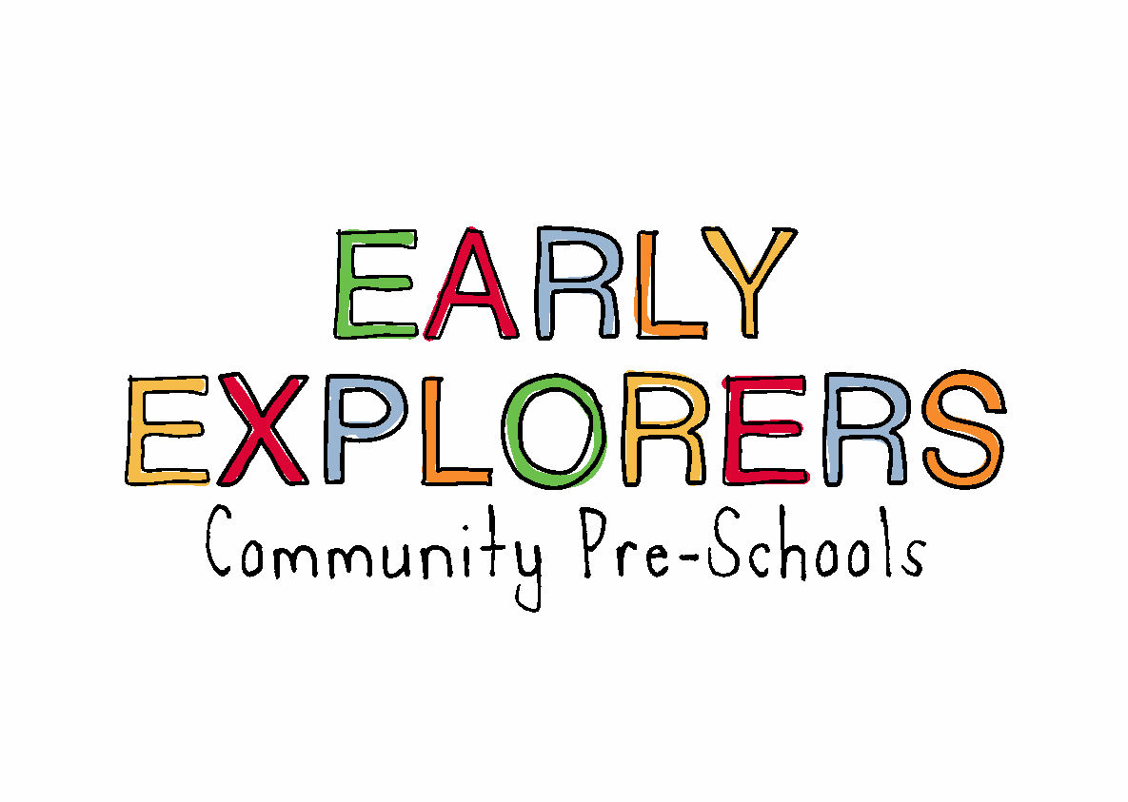
04. Health procedures
04.6 Oral health
Early Exploreres Community Pre-Schools provide care for children and promotes health through promoting oral health and hygiene, encouraging healthy eating, healthy snacks and tooth brushing.
- Fresh drinking water is always available and easily accessible.
- Sugary drinks are not served.
- In partnership with parents/carers, babies are introduced to an open free-flowing cup at 6 months and from 12 months are discouraged from using a bottle.
- Only water and milk are served with snacks.
- Children are offered healthy nutritious snacks with no added sugar.
- Parents/carers are discouraged from sending in confectionary as a snack or treat.

Pacifiers/dummies
- Parents/carers are advised to stop using dummies/pacifiers once their child is 12 months old.
- Dummies that are damaged are disposed of and parents/carers are told that this has happened
Further guidance
Infant & Toddler Forum: Ten Steps for Healthy Toddlers www.infantandtoddlerforum.org/toddlers-to-preschool/healthy-eating/ten-steps-for-healthy-toddlers/

